FOREST SURFACE OCCUPIED BY MONARCH BUTTERFLY HIBERNATION
COLONIES IN DECEMBER 2013

E. RENDÓN-SALINAS1 & G. TAVERA-ALONSO2
1World Wildlife Fund-México, Jaime Torres Bodet No. 22, Col. Poetas, 61500, Zitácuaro, Michoacán
2 Reserva de la Biosfera Mariposa Monarca, Cuauhtémoc Ote. No.34, Esq. Manuel Altamirano, 61504, Zitácuaro, Michoacán

Executive Summary
During the second half of December 2013, we registered 7 Monarch butterfly colonies (3 in Michoacán, 4 in the State of Mexico) that occupied 0.67 hectares (ha): 5 colonies (0.62 ha) inside the Monarch Butterfly Biosphere Reserve and 2 (0.05 ha) outside the reserve. This accounts for a 43.7% decrease compared to December 2012 (1.19 ha) and is the smallest area occupied by this butterfly in Mexican sanctuaries since 1993, when data are available.

Introduction
Monarch butterflies (Danaus plexippus) that hibernate in Mexico migrate for more than 4,000 km from the United States and Canada to establish their colonies in 11 sanctuaries along the border between the states of Michoacán and the State of Mexico (Fig.1). These forests are mainly populated by oyamel fir and pine-oak pine trees that provide the appropriate weather conditions for Monarch butterflies during the winter (Rendón-Salinas et al. 2004-2012).

The main threats for the Monarch butterfly in its range in North America are: (i) deforestation and forest degradation by illegal logging of overwintering sites in Mexico; (ii) widespread reduction of breeding habitat in the United States due to land-use changes and the decrease of this butterfly´s main larval food plant (common milkweed, Asclepias syriaca) associated with the use of glyphosate herbicides; and (iii) periodic extreme weather conditions throughout is range during the year (Vidal et al. 2013). These threats combined are responsible for the dramatic decrease over the last decade in the number of Monarch butterflies in the hibernation colonies in Mexico, which reached a 20-year low during the 2012-2013 season (Rendón-Salinas et al. 2012, Rendón-Salinas & Vidal, in preparation).

The loss of milkweed due to the use of herbicides in the USA Midwest is a main contributor to the decline in the Monarch population between 1999 and 2010 (Pleasants & Oberhauser 2012). Mexican authorities effectively enforced efforts to protect the Monarch Reserve, particularly from 2007 to 2012. Those efforts, together with the decade-long financial support from Mexican and international philanthropists and businesses to create locate alternative-income generation and employment to local communities, resulted in the decrease of large-scale logging in the core zone of the reserve (Vidal et al. 2013).

Since 2004, the Alianza WWF-Telcel in coordination with the National Commission for Protected Areas (CONANP) from the Secretariat of Environment and Natural Resources (SEMARNAT) has monitored the Monarch butterfly colonies in Mexico. Those data are being analyzed in detail and will be included in a peer- reviewed scientific journal in 2014 (Rendón-Salinas & Vidal, in preparation).

In this report we present the forest area occupied by Monarch colonies during the 2013-2014 season, using the forest area occupied buy these butterflies as an indirect indicator of their population density.

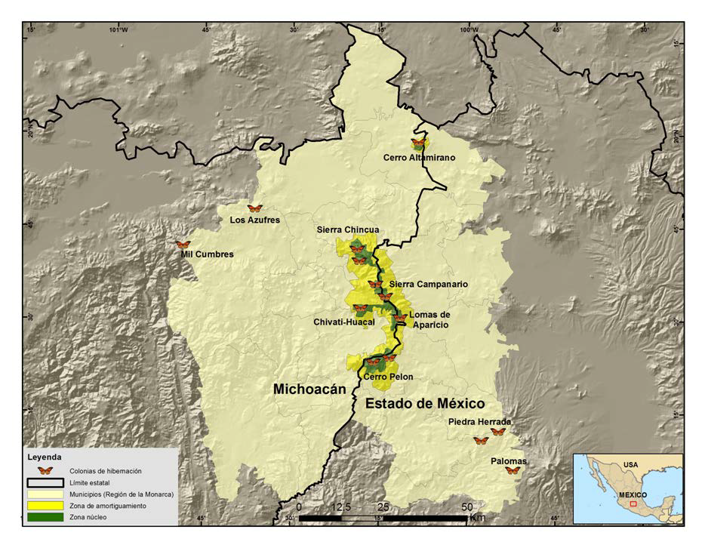
Figure 1. Historical overwintering colonies of the Monarch butterfly.

Method
Every 15 days, from 1 December 2013, we monitored 11 sanctuaries with historical presence of Monarch butterflies, registering their location with a Garmin® geopositioner in UTM projection and datum WGS 84, starting from the peripheral tree at the highest point of the slope. From this tree, using a compass and topographic surveying lines, we registered the perimeter of the colonies based on the direction and distance of consecutive peripheral trees occupied by butterflies. With the data from the perimeter, we drew the polygon and determined the area occupied by the colony using an Arc View 3.3 geographic information system. We recorded air temperature at 07:00 am in the Sierra Chincua sanctuary during November and December with a hydrometer and Abbeon Cal Inc temperature sensor installed in the Llano de las Papas, Angangueo, Michoacán.

Results
During the second half of December 2013, we registered 7 Monarch butterfly colonies (3 in Michoacán, 4 in the State of Mexico) that occupied 0.67 hectares: 5 colonies (0.62 ha) inside the Monarch Butterfly Biosphere Reserve and 2 (0.05 ha) outside the reserve. This accounts for a 43.7% decrease from December 2012 (1.19 ha) and is the smallest area occupied by this butterfly in Mexican sanctuaries since 1993 (Rendón-Salinas et al. 2012).

Table 1. Hibernation colonies and forest area occupied during December 2013

Location | State | Sanctuary | Colonies (Properties) | Area (ha)
Inside the reserve | State of Mexico | Cerro Pelón | E. El Capulín | 0.03
 |  |  | E. Mesas Altas de Xoconusco | *
 |  |  | C. I. San Juan Xoconusco | *
 |  |  | C.I. San Pablo Malacatepec | 0.04
 |  | Sierra Campanario | E. La Mesa | *
 | Michoacán | Cerro Altamirano | E. Contepec | *
 |  | Cerro Pelón | E. Nicolás Romero | *
 |  | Chivati-Huacal | C. I. Carpinteros | 0.01
 |  | Sierra Campanario | E. El Rosario | 0.52
 |  | Sierra Chincua | E. Cerro Prieto | 0.02
 |  |  | E. El Calabozo Fracción 1 | *
 |  | Lomas de Aparicio | E. Crescencio Morales | *
Outside the reserve | State of Mexico | Cerro del Amparo | E. San Francisco Oxtotilpan | *
 |  | Palomas | E. San Antonio Albarranes | 0.02
 |  | Piedra Herrada | E. San Mateo Almomoloa | 0.03
 | Michoacán | Los Azufres | P. P. San Andrés | *
 |  | Mil Cumbres | E. Río de Parras | *
Subtotal | 0.05
Total are occupied area Superficie total ocupada | 0.67
E- Ejido; C.I. – Indigenous Community and P.P. Small property * No colony found

Colonies in the reserve occupied 0.62 ha (92.5% of total area) and colonies outside the reserve occupied 0.05 ha (7.5%). The largest colony (0.52 ha or 77.6% of the total) was found in El Rosario (sanctuary of Sierra el Campanario, Municipality of Ocampo, Michoacán) and the smallest colony (0.01 ha) was found in the C.I. of Carpinteros, Michoacán. For the second time, a colony was found in C.I. San Pablo Malacatepec, State of Mexico. Butterflies were seen flying in the Mil Cumbres sanctuary, Michoacán, while in sanctuaries Los Azufres (Michoacán) and Cerro del Amparo (State of Mexico) we only found remains of dead butterflies. In November temperatures ranged between 4 and -2°C and in December between 4 and -3°C. There was intense cold weather (1 to -3°C) between November 28 and December 6, and from December 17 to 21 (0 to -2°). No extreme winter storms were reported (Fig.2).

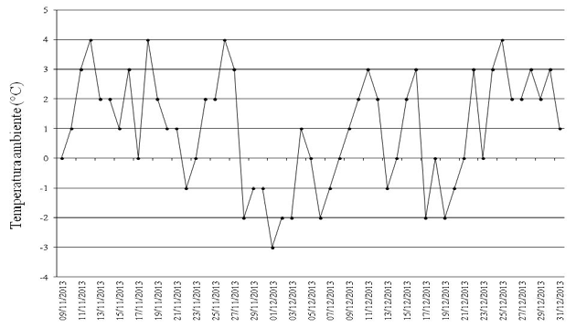
Figure 2. Temperature in the Sierra Chincua sanctuary, Michoacán.
Forest surface occupied by Monarch colonies in overwintering sites (0.67 ha) during the season 2013-2014 is the lowest since 1993 (Fig. 3)
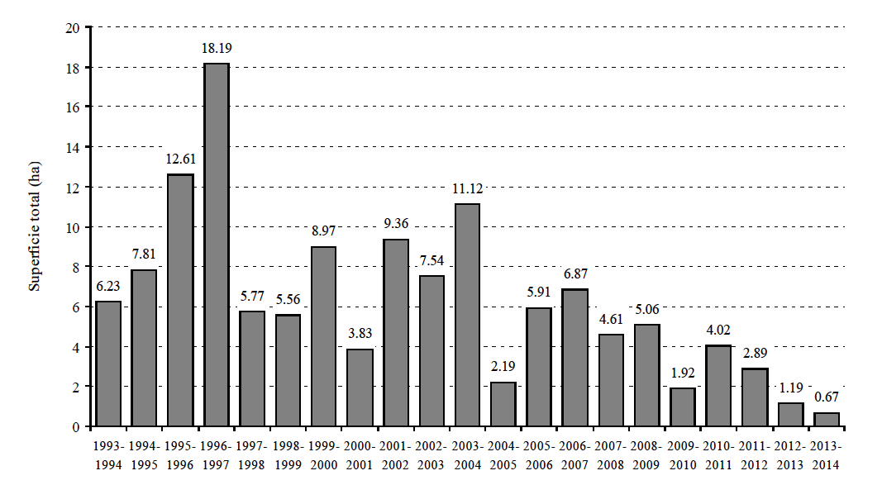
Figure 3. Forest occupied by Monarch butterfly colonies in Mexico 1993-1994/2013-2014 (Rendón-Salinas & Vidal, in preparation).

Literature cited
Pleasants, J.M. & K. Oberhauser. 2012. Milkweed loss in agricultural fields because of herbicide use:
effect on the monarch butterfly population. Insect Conservation and Diversity 6: 135-144.
Rendón-Salinas, E. & C. Galindo-Leal. 2004. Reporte preliminar del monitoreo de las colonias de hibernación de la mariposa Monarca. WWF-México, DF, unpublished, 9 pp.
Rendón-Salinas, E., A. Valera-Bermejo, M. Cruz-Piña, S. Rodríguez-Mejía & C. Galindo-Leal. 2005. Monitoreo de las colonias de hibernación de mariposa Monarca: superficie forestal de ocupación en diciembre de 2005a. WWF-México, DF, unpublished, 6 pp.
Rendón-Salinas, E., S. Rodríguez-Mejía, M. Cruz-Piña & C. Galindo-Leal. 2006. Monitoreo de las colonias de hibernación de mariposa Monarca: superficie forestal de ocupación en diciembre de 2006. WWF-México, DF, unpublished, 6 pp.
Rendón-Salinas, E., N. Acevedo-Hernández, S. Rodríguez-Mejía & C. Galindo-Leal. 2007. Monitoreo de las colonias de hibernación de mariposa Monarca: superficie forestal de ocupación en diciembre de 2007. WWF-México, DF, unpublished, 8 pp.
Rendón-Salinas, E., C. A. Valera-Bermejo & F. Martínez-Meza. 2008. Monitoreo de las colonias de hibernación de mariposa Monarca: superficie forestal de ocupación en diciembre de 2008. WWF-México, DF, unpublished, 8 pp.
Rendón-Salinas, E., C. A. Valera-Bermejo, S. Rodríguez-Mejía & F. Martínez-Meza. 2009. Monitoreo de las colonias de hibernación de mariposa Monarca: superficie forestal de ocupación en diciembre de 2009. WWF-México, DF, unpublished, 8 pp.
Rendón-Salinas, E., C. A. Valera-Bermejo, M. Cruz-Piña & F. Martínez-Meza. 2010. Monitoreo de las colonias de hibernación de mariposa Monarca: superficie forestal de ocupación en diciembre de 2010. WWF-México, DF, unpublished, 8 pp.
Rendón-Salinas, E., S. Rodríguez-Mejía, M. Cruz-Piña, C. A. Valera-Bermejo & F. Martínez Meza. 2011. Monitoreo de las colonias de hibernación de mariposa Monarca: superficie forestal de ocupación en diciembre de 2011. WWF-México, DF, unpublished, 8 pp.
Rendón-Salinas, E. & G. Tavera-Alonso. 2012. Monitoreo de la superficie forestal ocupada por las colonias de hibernación de la Mariposa Monarca en diciembre de 2012. WWF-México, DF, unpublished, 6 pp.
Vidal, O., J. López-García y E. Rendón-Salinas. 2013. Trends in deforestation and forest degradation after a decade of monitoring in the Monarch Butterfly Biosphere Reserve in Mexico. Conservation Biology. http://onlinelibrary.wiley.com/doi/10.1111/cobi.12138/full

