

**2014 Smart Gear Grand Prize Winner: Seine Fisheries**

**Air-powered Sampling Trawl Reduces Bycatch in Purse Seine Fisheries wins $30,000**

The 2014 Smart Gear grand prize of $30,000 was awarded to a Norwegian team whose device addresses bycatch in purse seine fisheries. This “Air Powered Sampling for Purse Seine Fisheries,” allows fishers to check the contents of the net in the early phase of fishing, about 40-50 meters away from the vessel, avoiding crowded nets, fish stress, and physical damage. Using an air cannon, a sampling tube containing a mini-trawl is launched into the net to collect a representation of the fish. A hydraulic winch is then used to haul the net in for inspection. If the sampled fish are deemed unwanted catch, the seine is opened up to release them. Conducting this sampling process at such an early stage secures greater survival of fish should they need to be released. The grand prize winning team includes: Bjoernar Isakesen, Kurt Hansen, and Jostein Saltskaar.

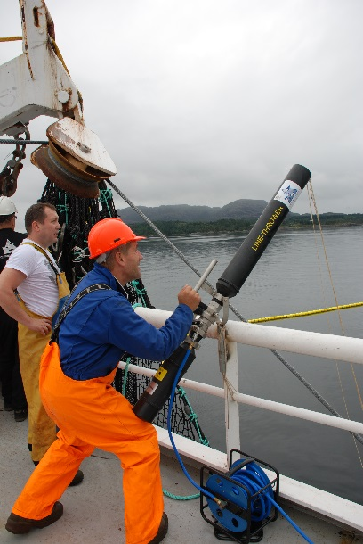 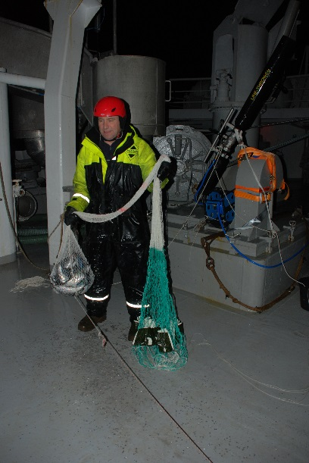 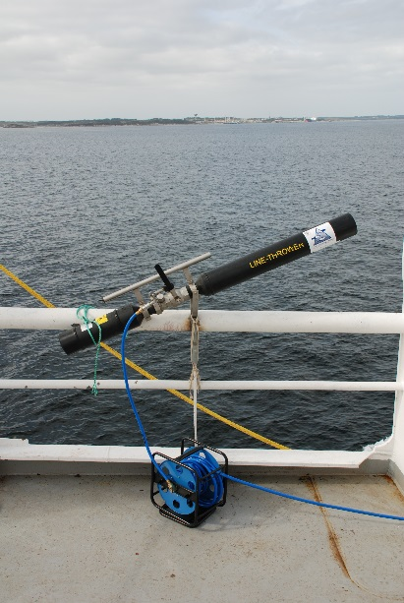s

Purse seine fisheries are traditionally known as “volume fisheries” housing fish such as mackerel, herring, capelin, anchovy and sardines. Well-established catch procedures often result in low-priced fish having to be released from alongside the vessel as fishers are unable to take the whole catch on board either due to it being the wrong size and/or quality. In the past the release of such fish was not considered a problem, but survival experiments performed in the last 5-8 years have revealed a substantial unaccounted mortality from a few hours to a few days after the actual release. In an attempt to avoid bringing the catch alongside the vessel to get a sampling of the catch, participants from the Institute of Marine Research (Bergen, Norway) and SINTEF Fisheries and Aquaculture (Hirtshals, Denmark) started an R & D project in 2012.

After two years in development, a system for collecting samples of fish in the early phase of pursing—before the catch is brought alongside the ship when stress level of fish is low, and contact between fish and net is minimal—is ready to be introduced as a sampling tool for the purse seine fleet. The ability to reveal the size and quality of the fish catch from the mini trawl sampling allows fishers to open the seine and the unwanted fish to swim freely out of the gear.

This air-powered sampling technique is a new and innovative way of bringing samples of fish on board without causing them unmanageable stress or lethal injury.

**Meet the Team**

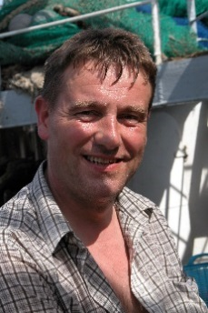**Jostein Saltskaar**

Born in 1963 on a small island in the western part of Norway—where the fjords meet the open North Sea—Saltskaar grew up in a fisherman’s family, among a community with a high competence in coastal purse seine fishery. From an early age, the sea, fisheries, boats, and engines were all part of his daily life. or as he loves to state: “my father’s purse seiner was my kindergarten during the summer months”.

In addition to a well-rounded education, Saltskaar has 12 years’ experience of various work on both large and small fishing vessels, mainly purse seiners. From 2001 he has been working as a technician at Fish Capture Division, Institute of Marine Research (IMR). His main field of work has been on the different aspects of purse seiners as well as Scottish seine technology.

As a part of the team at IMR—but perhaps as early as a fisherman—Saltskaar realized the implications of bycatch. The idea of a sampling device was originally proposed by Saltskaar out of sheer curiosity. However, as the idea was discussed more in-depth, the more it turned into reality. Saltskaar has been the main promoter for the sampling device since the idea was launched.

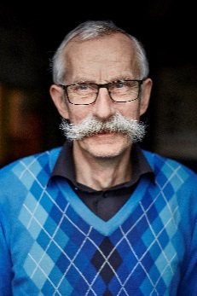**Kurt Hansen**

Kurt Hansen has a master’s degree in mechanical engineering from the Technical University of Denmark. He worked as a propeller designer in a marine diesel factory before he joined the Danish Fisheries Technology Institute.

Hansen’s main role in the project was the design of the sampling trawls, including the opening devices attached to the trawls. Flume tank tests played an important role in the development of the gear. He also participated in the tests at sea to investigate if the performance of the trawl gear was as it was intended. He enjoys jobs like this where the objective is to develop and test practical solutions to technical problems.

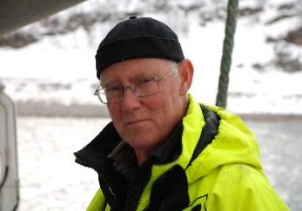**Bjoernar Isaksen**

Isaksen was born in 1949 on a small island in the outback of northern Norway. He grew up in a typical fisherman’s family—a small, farmer society, where austerity and hard work were the main condition to survive in an otherwise rough and sparing community.

Fishing and its related gear was an early interest for Isaksen, quickly becoming his most valued hobby. However, as his reading skills fell far above the standard for his age, he was pushed towards a future in academia, rather than entering his father’s world on board a coastal gillnetter.

After earning his bachelor’s degree from the University of Oslo, he went on to receive a master’s degree in fishery biology from the University of Bergen—an accomplishment to which he attributes his ‘good fortune’ in earning a position in 1977 at The Institute of Fishing Technology Research in Bergen. Since 1991 he has been working at the Fish Capture Division at the Institute of Marine Research, overseeing a wide range of fishing gear related work—both domestic and international. A recurring theme throughout his years in this career has been selectivity in fishing gear, such as ground fish trawls, shrimp trawls, big pelagic trawls and Scottish seine. When the Fish Capture Division recruited a purse seine expert in 2001, gear technicians soon became close teammates. Slowly, focus on selectivity has switched from active gear like trawls and Scottish seine, to technologies for purse seine sampling.

**2014 Smart Gear Runner up: FRESWIND**

**Bycatch reduction device wins $10,000**

FRESWIND is an innovative flatfish bycatch reduction device intended for demersal roundfish fisheries. The concept for this devise is based on a sequential selection process for flatfish and roundfish species, an improved selection device and the alteration of flatfish behavior. The device was designed by a multi-disciplinary team composed by fishing technologists from the German Thünen Institute for Baltic sea fisheries (Bernd Mieske, Juan Santos, Annemarie Schuetz and Daniel Stepputtis), the Swedish University of Agricultural Sciences (Hans Nilsson), the Norwegian company SINTEF Fisheries and Aquaculture (Bent Herrmann) and by Swedish fisherman, Vilnis Ulups.

FRESWIND is a species selection device, using the differences in morphology between flatfish and roundfish species to improve the selectivity of trawl gears. Because of differences in the morphology of flatfish and roundfish, flatfish predominantly have poor selectivity in standard cod-ends, resulting in large amounts of unwanted bycatch. The retained flatfish go on to have a negative effect on the roundish selectivity as it continuously clogs the net.

The FRESWIND approach can be broken into three primary objectives:

1. To establish sequential selectivity by mounting specific devices for different species in different part of the trawl.
2. To design an escape device optimized for flatfish species.
3. To alter the behavior of flatfish within the trawl to improve the probability of contact between fish and the escape device.

Selective properties for flatfish species are achieved by a specific design based on two lateral escape windows that are mounted in front of the cod-end. The spacing of the bars are horizontally positioned to match the flatfish body shape in natural swimming orientation. Regional catch profile preferences must be considered in order to specify the optimal bar spacing of the windows. Spacing must be carefully assessed to allow the escape of a wide range of flatfish size classes while only undersized fish would have the chance to escape through such windows. Each of the windows are fitted to the sides of a 4 panel extension piece designed to provide stability to ensure the optimal position of the windows during the fishing process. Additionally, the windows are positioned with a 45 degree angle in relation to the towing direction, creating a tapering effect, which enhances the fish contacts with the escape windows. To further increase the contact probability between the fish and escape windows, a guiding device made of canvas was attached ahead of the windows to alter the flatfish swimming direction sideways towards the windows.

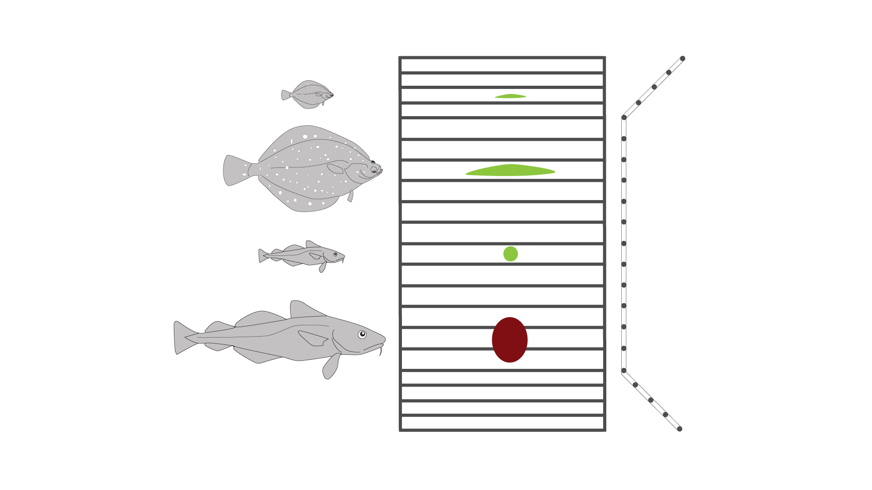

**Figure 1:** schematic presentation of the flatfish escapement window used in FRESWIND. Left: different demersal fish species and sizes); Mid: window with bar spacing and cross section of fish, green color of the cross section indicates successful penetration of the selection device; Right: cross section of window.

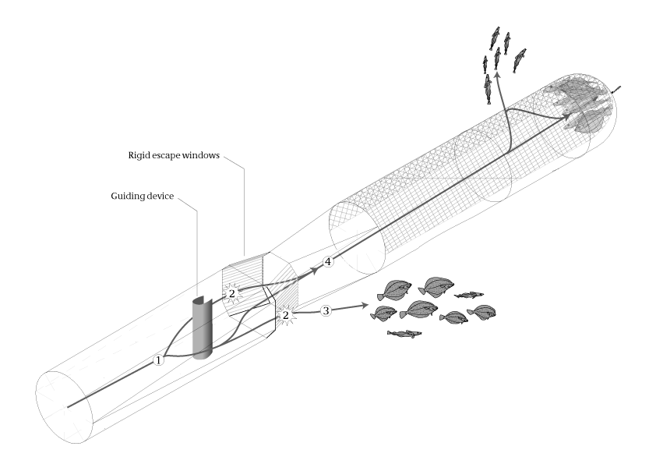

**Figure 2:** Sequential selection system with FRESWIND mounted in front of a BACOMA codend. (1) Fish entering the extension piece are guided sideways by the canvas device and (2) will contact the escapement window. (3) Fish escapement depending on the size selection in the FRESWIND escapement window. (4) Fish which did not efficiently contact, or were not able to escape through the rigid windows (because they were too large) follow the path towards the codend (4) where a successive, roundfish-directed selection process takes place.

**Meet the Team**

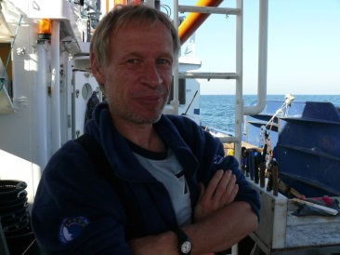**Bent Herrmann**

Herrmann earned his MSc in Engineering, specializing in physics, from Aalborg University in Denmark 1985. He later went on to pursue his PhD in Modelling and Simulation in trawl selectivity from the same university. He has worked for more than a decade with species and size selectivity in fishing gears. Herrmann is currently employed as a Senior Scientist for SINTEF Fisheries and Aquaculture in their Denmark office. He also works part-time at the University in Tromsø (Norway) with a special attention to fishing gear technology. His research revolves around computer-based methods for analysis and simulation of fishing gear selectivity.

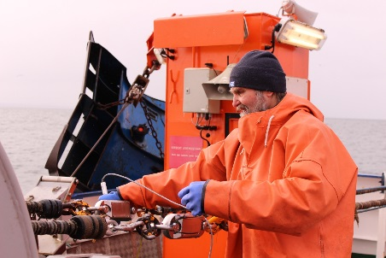**Bernd Mieske**

Mieske is an engineer, graduating with a degree in Fishing Technologies. He has many valued years of experience in the design of fish cages and trawl gear. As a member of the fishing technology working group at the Thünen-Institute for Baltic Sea Fisheries, he is responsible for gear design and sea trials.

**Hans C Nilsson**

Nilsson earned his PhD in Marine Zoology from Gothenburg University in 1998. While earning his degree, and for years after, Nilsson’s primary area of research was benthic ecology and the benthic fauna response to hypoxia. In 2011, he started a new position at the Swedish Board of Fisheries and started to get more heavily involved in projects concerning selectivity and fishery science.

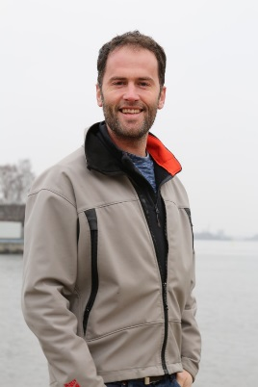 **Juan Santos**

Santos enrolled in fisheries science ten years ago as observer onboard different Spanish fishing vessels. Starting his first cruise, he recognized bycatch as one of the biggest issues in industrial fisheries. Based on his earlier experiences at sea, he decided to orientate his career into the field of fishing technology and trawl selectivity. In 2013 he moved to Germany to join the fishing technology working group at the Thünen-Institute for Baltic Sea Fisheries. His professional interests include the development and testing of multispecies selection systems, experimental design, conduction of selectivity sea trials and statistical modeling. In his free time, he likes to engage in activities which take him away from computers and the digital world.

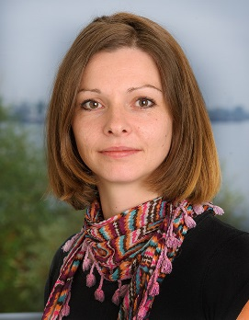**Annemarie Schütz**

Schütz started her professional career as a media designer in the printing industry, and during that time she gained considerable experience in multimedia and web communication. She currently uses her expertise to help colleagues in the Thünen-Institute to communicate their research to society. In her free time, she loves spending time with her daughter and going out into nature for hiking or horse riding.

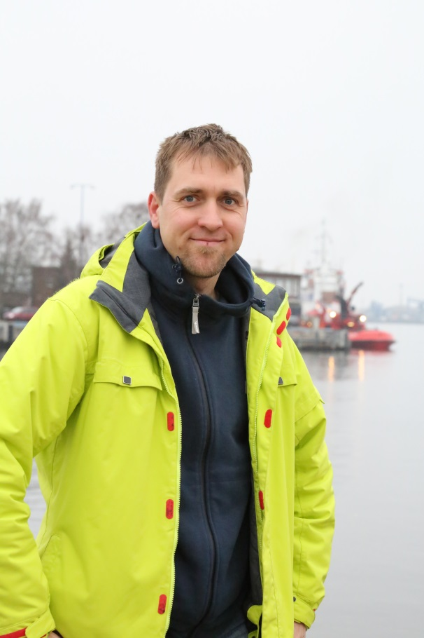**Daniel Stepputtis**

With a diploma and Phd in Marine Biology / Fishery Biology (focus on hydroacoustics), Daniel is leading the working group of fishing gear technology and survey technology at the Thünen-Institute of Baltic Sea Fisheries in Rostock (Germany). At present, one of the main research topics is the development of concepts for multispecies selectivity in trawls, taking into account morphological and behavioural differences between species. He and his team are conducting research on alternative selectivity approaches and other fishing techniques, such as gill nets, fish pots and pulse fishing. He is also working on technologies to support research surveys. During his spare time, Daniel spends as much time as possible with his children, plays the saxophone and partakes in underwater rugby.

**Vilnis Ulups**

Ulups is a Swedish skipper, who has been involved in different Baltic fisheries for the last 45 years. During this time he gained a wealth of experience on different fishing methods and technology applied in fisheries, such as gillnet, longline and trawl fisheries. Through his work, Ulups has gained a deep insight into the problem of bycatch and participated in different selectivity sea trials. He provided the FRESWIND team with the original rigid window design as a solution to reduce flatfish bycatch in roundfish fisheries. In his spare time, Ulups enjoys traveling by motorcycle to different places where he can meet new people and diverse ways of life.

**2014 Smart Gear Runner up: Super PolyShark**

**Time release repellent to control shark bycatch wins $10,000**



The Super Polyshark, designed by Florida researchers, Dr. Eric Stroud and Dr. Patrick Rice, is a shark bycatch reduction device which uses time-released pellets that, when dissolved in water, create an odor that repels sharks. The pellets, made up of a selective semiochemical, are inserted into the squid bait before being placed on longline hooks. This nontoxic and biodegradable repellent has achieved a 71% difference in shark catch between treated and control baits over a four hour window.

The device itself is a simple three-component system. A paper tube holds a polymer containing the shark repellent. This tube is then cut into “nuggets”, or pellets, about 7.5 cm tall. These are then inserted in to the longline bait. An exterior comparison shows no distinguishable characteristics between a control squid and one containing the Super Polyshark pellet. Target fish, as well as bony fish like tuna and swordfish, do not detect the semiochemical and therefore their catch rate remains unchanged.

*Super Polyshark pellets and Super Polyshark pellets*

*installed into squid. Control squid and treatment squid*

*have similar appearance.*

Super Polyshark is the first successful chemical repellent device designed to selectively reduce shark bycatch by utilizing a time-released polymer. Consisting of only three materials—a paper shell, a polymer, and a semiochemical (all environment-friendly and cost effective)—the actual deployment of the device requires minimal labour for fishermen. Currently there are two options for fishermen who choose to use the Super Polyshark: the pellet of the Super Polyshark is inserted into the mantle of a quid prior to baiting the hook, or; fishermen can purchase bait with the pellets already enclosed. Both the polymer and the repellent are stable throughout a freeze-thaw cycle, and a complete dissolve of the repellent is completed within 16 hours of contact with water.

|  |  |  |
| --- | --- | --- |
|  |  |  |
| *Paper tubes are sealed at one end with rapidly-cooled polymer* | *Molten polymer with repellent is poured into the tubes and cooled quickly* | *Once cooled, Polyshark is a hard solid in air, and stores indefinitely.* |

**Meet the Team**

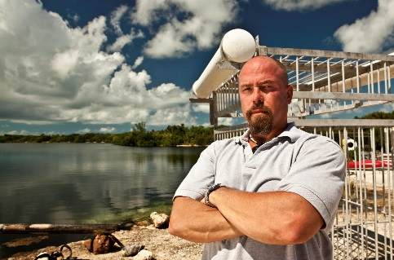**Dr. Patrick H. Rice**

Dr. Rice is currently the Dean of Career, Technical & Workforce Education and the Principal Investigator for Marine Research at Florida Keys Community College (FKCC). He earned his Ph.D. in Marine Biology & Fisheries from the University of Miami in 2008 at the Rosenstiel School of Marine and Atmospheric Science (UM-RSMAS) and is the principal investigator for current NOAA fisheries research focused on employing shark repellent technology to reduce shark bycatch during commercial pelagic longline fishing. Dr. Rice was a National Science Foundation Fellow for the Japanese Monbusho Program to study mariculture in Japan, where his primary focus was on culturing bluefin tuna (*Thunnus thynnus orientalis*). Prior to Master’s studies, Dr. Rice was a volunteer for the United States Peace Corps in South Pacific Islands of Fiji providing protein to indigenous people through aquaculture education. Dr. Rice earned his Bachelor of Science degree in Biology from the University of Texas – Austin in 1992.

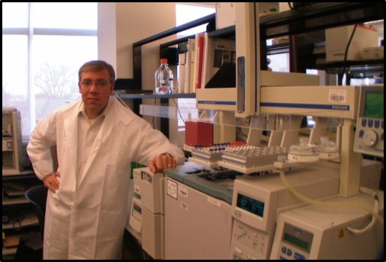**Dr. Eric M. Stroud**

Dr. Stroud is co-founder and managing partner of Shark Defense Technologies LLC. He earned his Ph.D. in Organic Chemistry at Seton Hall University in 2013, and was the principal investigator for two National Science Foundation SBIR awards for an innovative shark repellent technology for terminal fishing tackle. Dr. Stroud has also secured a number of private and government research grants related to shark repellent technologies between 2005 and 2014, which focused on shark bycatch reduction in commercial fisheries. As a consultant to the pharmaceutical and medical device industry for the past twenty years, he has worked for all of the major global pharmaceutical companies, and has brought one medical device and five formulations from the laboratory to market.

Dr. Stroud supports Dr. Patrick Rice as a consultant for NOAA fisheries research focused on employing shark repellent technology to reduce shark bycatch during commercial pelagic longline fishing. Dr. Stroud earned his Masters of Science in Environmental Engineering and his Bachelor of Science (1995) in Chemical Engineering, both from the New Jersey Institute of Technology.

**2014 Smart Gear Special Prize Winner: Seabird Saver**

**Laser System Device Reduces Bird Bycatch**

The SeaBird Saver is an innovative bird deterrent device based on a laser system and optional acoustic stimulus to aggressively deter birds from dangerous fishing areas, ultimately reducing bird bycatch as well as fatalities while optimizing overall catch for fishermen. The two-person team is made up of Ernst Schrijver, marine biologist, and Wouter van Dam, product manager.

The SeaBird Saver is comprised of a mountable, flexible laser source and optional sound system; its deterring effect is made possible by a visual stimulus with a discretionary acoustic stimulus add-on—marketed separately but combined together to increase efficacy. The visual stimulus component is produced by a patented laser beam, emitting a beam that is easily widened for both optimal visibility and the reduction of possible retinal damage caused in birds due to the the unlikely event of long-term exposure. The laser beam itself is calibrated with the correct wavelength for bird eye sightability while simultaneously producing the optimal strength to be effective on liquid services. The laser beam and its scattering effect produces a powerful bird deterrent, especially effective during low visibility conditions—dawn, dusk, rain, and fog. Because most marine birds are threatened by the presence of the laser beam dot—understanding it to be an unnatural and unpredictable threat—their intuitive response is to avoid contact and fly away.

The acoustic stimulus element is generated by an innovative, high-energy sound system. It concentrates specifically designed sounds in a tight bundle of 15 degrees, creating a narrow and, as such, aimable sound “beam” designed to deter birds. Ernst Schrijver, marine biologist, was responsible for programming different sound signals in conjunction with other specialized sound engineers. Together they designed a scrambling of natural predator and distress calls, which demonstrated the highest success rate of deterrence among all the trials.

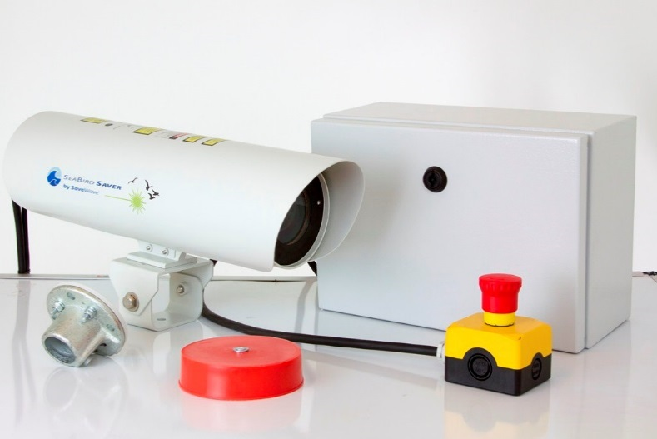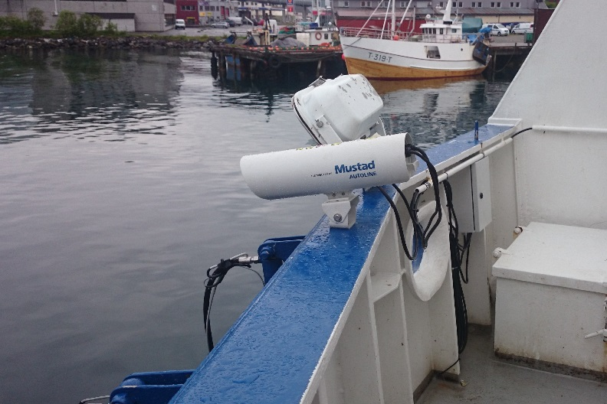

**The SeaBird Saver laser system Seabird Saver laser system mounted on a Norwegian longliner.**

**Meet the Team**

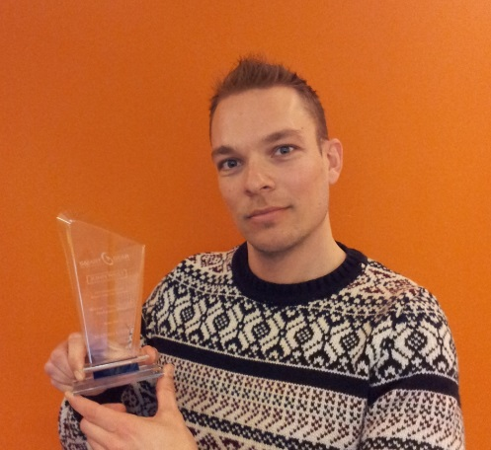**Wouter van Dam,** Product Manager

Ten years ago, Wouter started working at SaveWave, while still finishing up his academic studies in Communication Sciences. Intrigued by the nature of SaveWave’s work, Wouter dedicated his time to the company and became personally committed to sharing their mission. Now, almost ten years later, he is able to see how products are really starting to make a difference in the world. “It makes me proud when I can honestly say that our products are now saving sea life around the globe with solutions that are economically attractive for the fishermen,” Wouter says, “I believe winning the Smart Gear Special Tuna Prize will be a big boost in realizing our goals.”

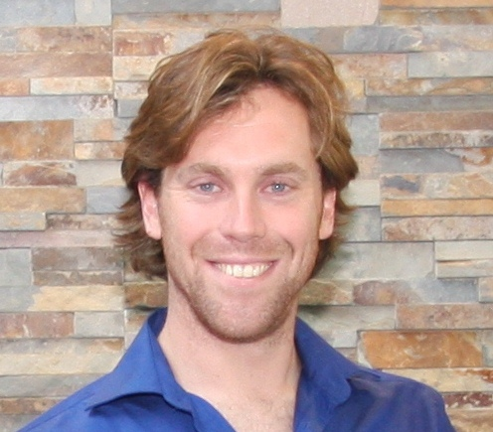**Ernst Schrijver,** Marine Biologist

Minimizing negative conflicts between marine life and fisheries has always been Ernst Schrijver’s personal motivation. In his current position at SaveWave, Ernst combines his passion for marine life with his eagerness to see the world and meet its people. “At SaveWave, we believe the knife has to cut on both edges,” says Ernst, “therefore, working together with fishermen is the best way forward to a more sustainable future.” It is his contention that the populations’ growing need for protein creates an undeniable sense of urgency to invest in the work ensuring sustainable and productive fisheries.