Peru’s Natural Legacy 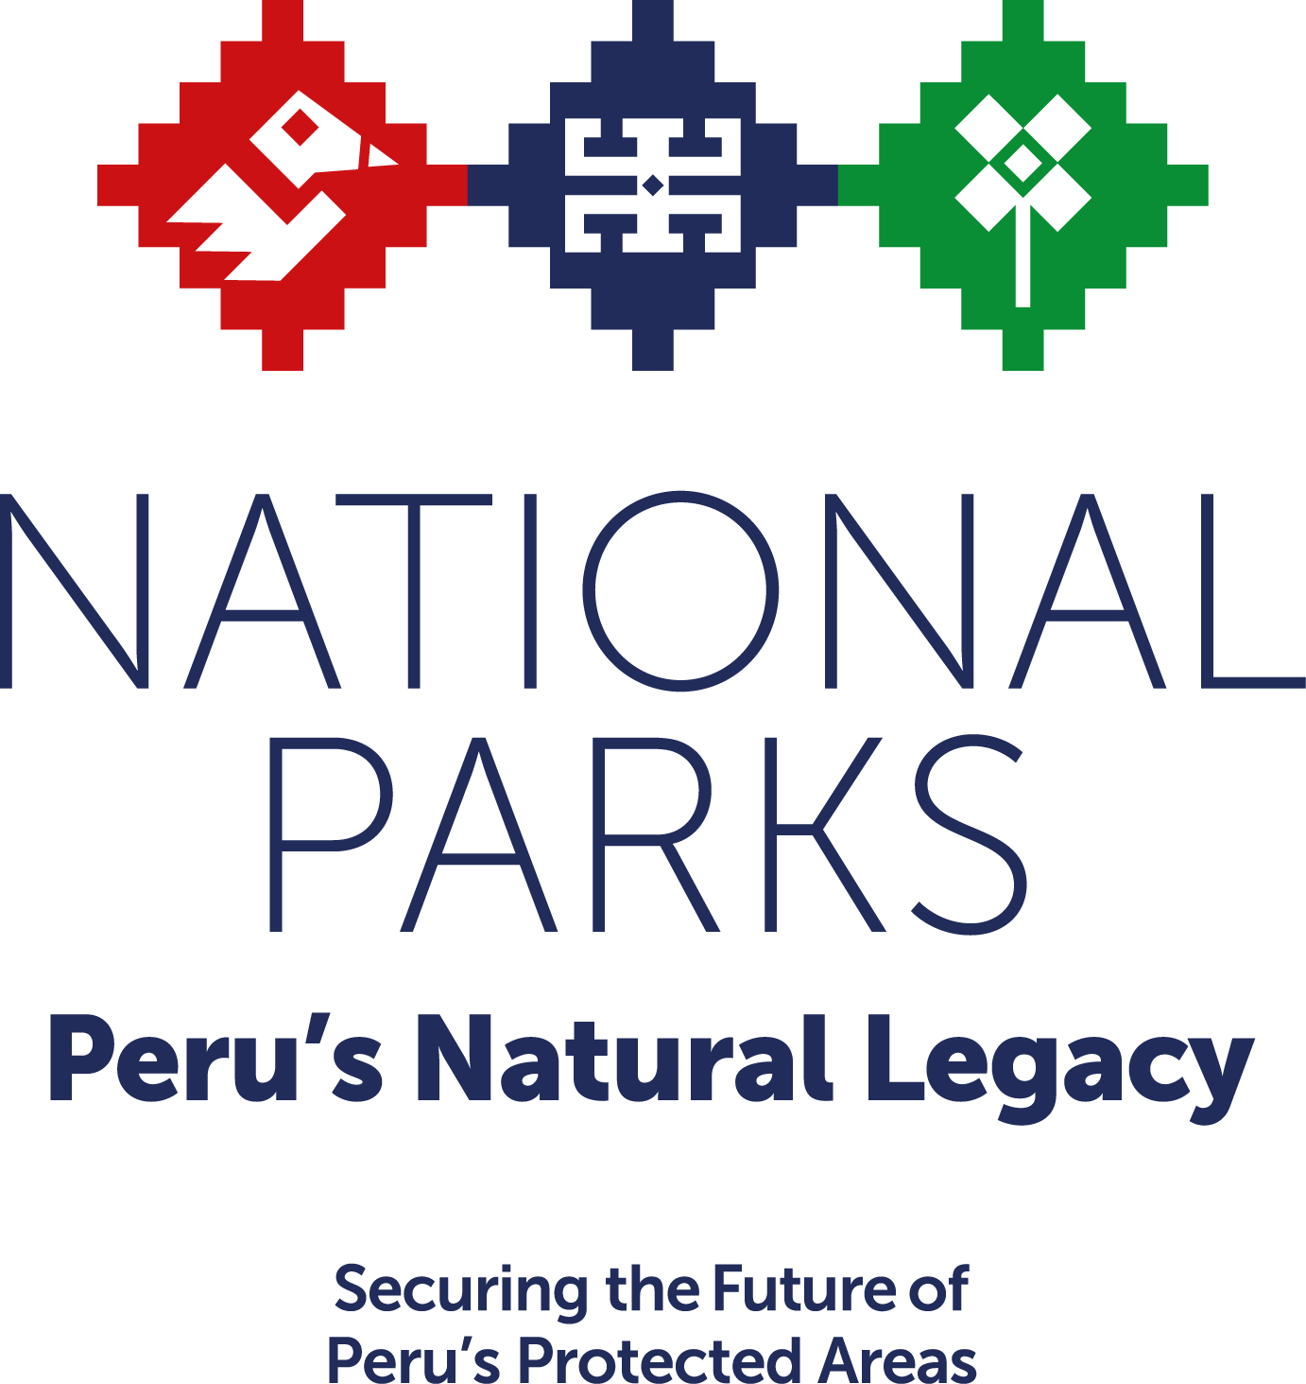
Securing the Future of Peru’s Protected Areas
Over the last 20 years, the government of Peru has established a comprehensive national system of protected areas that conserves biodiversity, prevents deforestation, provides valuable ecosystem services, and brings economic benefits to local communities. The Government of Peru has demonstrated its strong commitment to the National System of Protected Areas (SINANPE) by increasing its budgetary allocation by an average of seven percent annually from 2012 to 2016. But the system is still dependent on support from external donors and requires additional investment to achieve the level of management needed to ensure its ecological, economic and social benefits are sustained. The average annual gap between how much is needed to properly manage the network of protected areas and how much exists to do so is US$12 million.
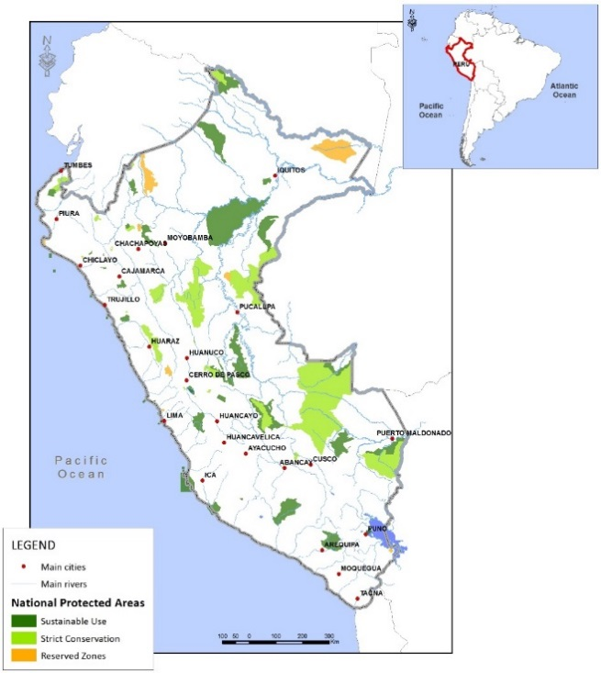
Unsustainable gold mining, logging and agriculture, as well as illegal logging and urban expansion in Peru, drive home the urgency to address this challenge. All of these drivers threaten Peru’s natural resources, which are essential to the survival of people and nature in Peru and globally. Peru, for example, ranks fourth in the world for having the most forest land—land that stores and absorbs carbon so that climate change is kept at bay, is a source of livelihoods for more than 330,000 people, and is habitat for thousands of the world’s most important species, such as jaguars and macaws.
The Solution: Permanent Funding
Peru has a historic opportunity to secure the investments in SINANPE that have been made by the government of Peru and donors over the past 20 years. The opportunity is an innovative public-private partnership—called National Parks: Peru’s Natural Legacy—that brings together government commitments, international cooperation and private donors. The partnership was born at an MoU signing during the World Parks Congress in November 2014. Its partners are committed to using an innovative funding model, called Project Finance for Permanence, which has been used successfully in Brazil for ARPA, in Costa Rica Forever and the Great Bear Rainforest in Canada.
Phase 1 of Peru’s Natural Legacy will focus on the long-term financial sustainability of 41 million acres in 38 existing and new protected areas in the Amazon. The funding will be used to hire and train park guards, buy equipment, build infrastructure, support participatory management, and more—all to ensure the benefits that Peru’s protected areas provide to its citizens and to the world remain for generations to come. The goal is to secure approximately $70 million in donor funding by the end of 2017.
The funding is being sought from donors in a single, comprehensive fundraising effort that—together with policies promulgated by the government to generate new sources of revenue for protected areas and the budgetary resources provided by the national government—will create a world class national park system. The system will no longer require additional donor funding to cover the recurrent costs of operation and will be self-sustaining in perpetuity.
Progress
Political will and partnerships in place: The initiative is being developed under the leadership of SERNANP Director Pedro Gamboa and Vice-Minister of the Environment Fernando Leon. The initiative also counts on the support and contributions of strong local non-governmental organizations including the Peruvian Society for Environmental Law (SPDA) and the Peruvian Trust Fund for National Parks and Protected Areas (PROFONANPE).
Assessment of climate mitigation impacts: Peru’s Amazon forests store over 6.7 billion MTC with 23% of that carbon (over 1.5 billion MTC) contained within protected areas, thus making them a major player in keeping the world’s climate change at bay. The initiative supports Peru’s National Strategy on Forests and Climate Change which recommends the consolidation of SINANPE as a key line of work.
Initial funding secured: The partnership has already been successful in securing an initial commitment of $9 million from the Global Environment Facility for the initiative under the Amazon Sustainable Landscapes program. The Gordon and Betty Moore Foundation has also indicated it is willing to commit up to $10 million to the initiative. WWF will raise additional funds from private donors outside of Peru to complement the public sector and international cooperation funds that will be needed to reach the $70 million fundraising goal.
Revenue sources assessed: A study of the potential legal and policy changes that could be made to generate sustainable funding flows for SINANPE has identified several promising options, including increasing protected area entrance fees and allocating payment for the hydrological services provided by protected areas to SERNANP.
Livelihoods research completed: A study of the social and economic benefits provided locally, nationally and globally by SINANPE highlights the increased incomes local residents living near protected areas have compared with those living in similar habitats without protected areas. This is important because nearly half of the 50 million acres of national protected areas are sustainable use areas that permit extraction of natural resources for the benefit of local communities. The value of the natural resources harvested from within protected areas is estimated at US $25 million annually.
Holistic approach: While working on this initiative, the Peruvian government and its partners also are trying to reduce illegal logging, and title indigenous lands. Together, these three initiatives will help transform the forest sector in Peru and protect the country’s most important natural resources.
Project Partners
Blue Moon Fund (now the Andes-Amazon Fund)
Gordon and Betty Moore Foundation
Peru Ministry of Environment
Peruvian National Parks Service
Peruvian Society for Environmental Law
Peruvian Trust Fund for National Parks and Protected Areas
World Wildlife Fund

